**CENWP-OD-B 19 July 2023**

**MEMORANDUM FOR THE RECORD**

**SUBJECT: 23BON060 MFR AFF Valve 15 Lamprey and Juvenile Salmonid Mortalities**

On the morning of 19 July, Columbia River Inter-Tribal Fish Commission (CRITFC) Biologists notified Bonneville Project Biologists of nine lamprey mortalities and one juvenile salmonid mortality found on the valve 15 trash rack in the Adult Fish Facility (AFF). The fish were scanned for PIT tags, inspected, and returned to the river.

1. Species – Pacific Lamprey (*Entosphenus tridentatus)*
2. Origin – Unknown
3. Length – (noted from top to bottom)
   1. Photo 1 66 cm, 69.2 cm, 72.4 cm, 55.2 cm, 63.5 cm, 76.2 cm
   2. 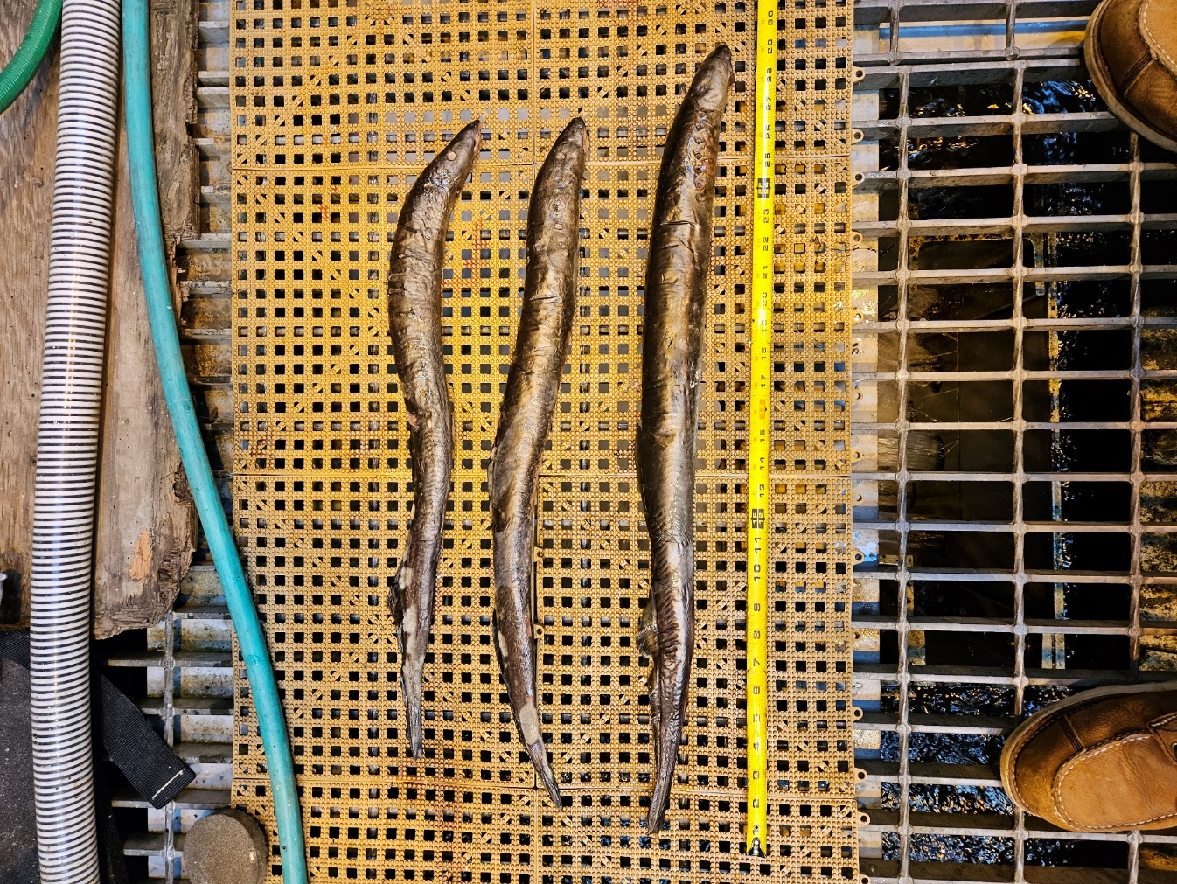Photo 2 - 62.2 cm, 64.8 cm, 73.7 cm
4. 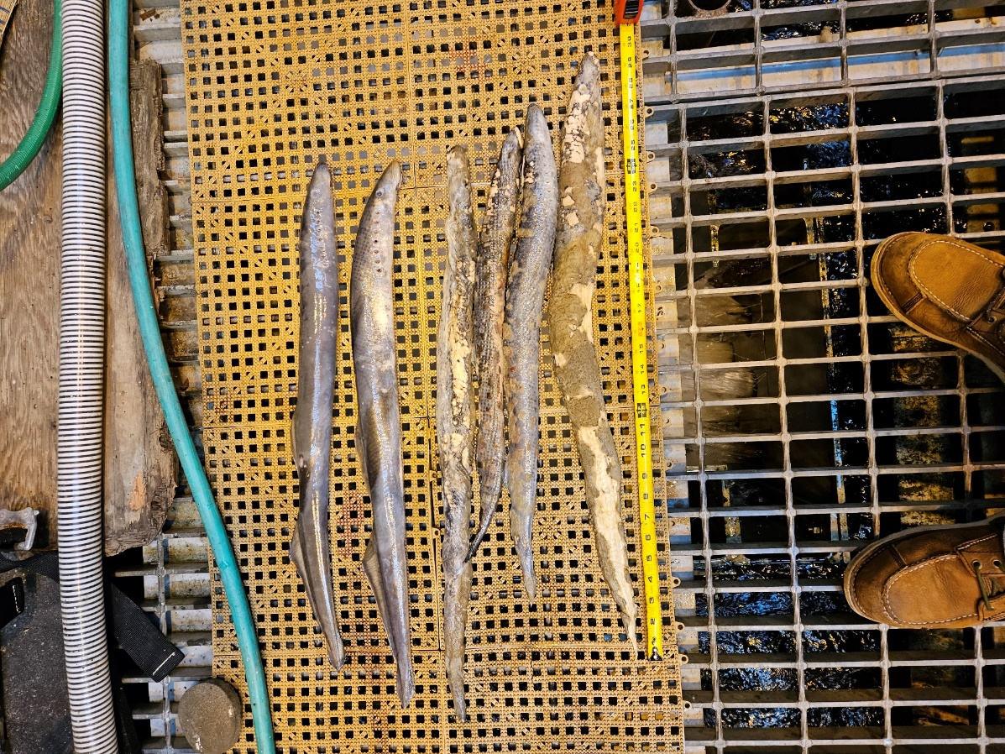Marks and tags – None
5. Marks and Injuries found on carcass – General decay
6. Cause and Time of Death – Unknown
7. Future and Preventative Measures – None

Photo 1. Photo 2.

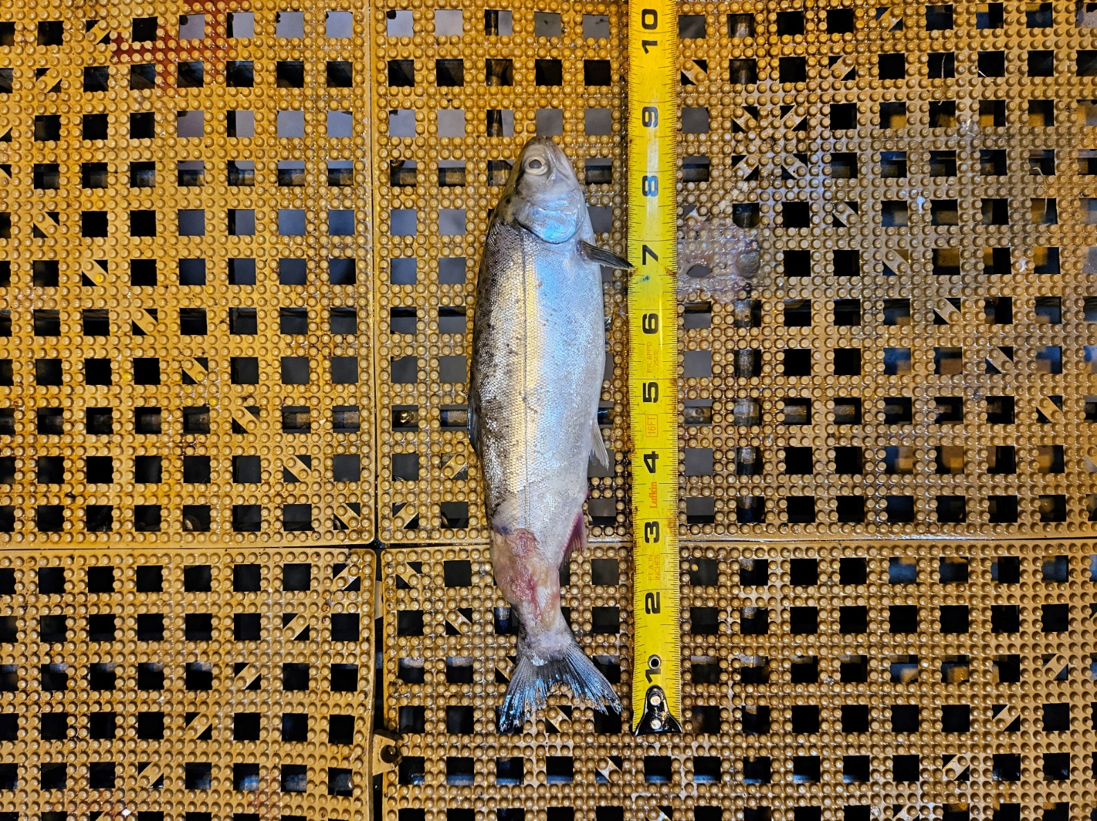

1. Species – Juvenile Salmonid
2. Origin – Unknown
3. Length –21.6 cm
4. Marks and tags – None
5. Marks and Injuries found on carcass – laceration along lateral line and caudal peduncle
6. Cause and Time of Death – Possible predation
7. Future and Preventative Measures – None

Sincerely,

Bonneville Project Fisheries